MISSING CAT
HELP US FIND OUR FURRY FRIEND

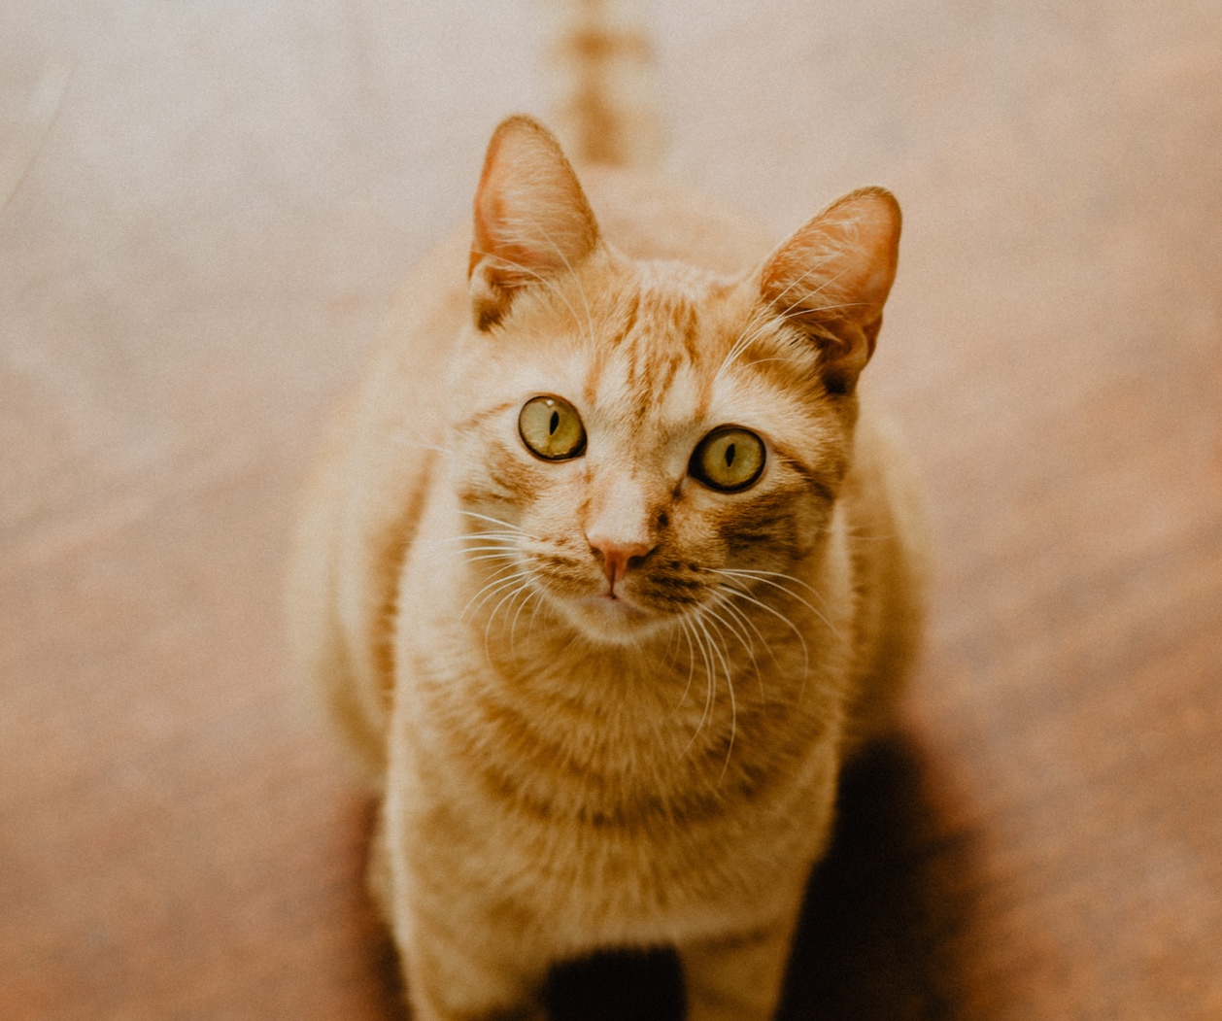
To replace this photo: Right click the image. Change Picture > From a File… Select the photo you want to use and click Insert. Don’t forget to delete this box before printing!

Description: Friendly neutered male. Orange tabby with stripes. Red collar with gold bell. Approximately 5 years old.

Missing since: Month XX, 20XX.
Last seen near 1234 Main Street, Colorado Springs

CALL OR TEXT WITH ANY INFO
(XXX) XXX-XXXX
MISSING DOG
HELP US FIND OUR FURRY FRIEND

$300 Reward

To replace this photo: Right click the image. Change Picture > From a File… Select the photo you want to use and click Insert. Don’t forget to delete this box before printing!

Description: Friendly female golden retriever. 3 years old. Pink collar.

Missing since: Month XX, 20XX.
Last seen near 1234 Main Street, Colorado Springs

CALL OR TEXT WITH ANY INFO
(XXX) XXX-XXXX

